Terms of referencE
Evaluation of the training programme for continous professional development of social protection staff in the former Yugoslav Republic of Macedonia

Contents
I. BACKGROUND AND CONTEXT 2
II. THE PROGRAMME 4
III. RATIONALE 6
IV. OBJECTIVE 6
V. SCOPE AND LIMITATIONS 7
VI. QUESTIONS 7
VII. METHODOLOGY 8
VIII. AVAILABILITY OF DATA/INFORMATION SOURCE 9
IX. WORK PLAN 10
X. TEAM COMPOSITION 10
XI. EVALUATION MANAGEMENT 11
XII. PRODUCTS TO BE DELIVERED and STRUCTURE OF EVALUATION REPORT 11
XIII. RESOURCES AND PAYMENT SCHEDULE 12
XIV. REMARKS AND RESERVATIONS 12

Annex 1 UNICEF Core Roles 14
Annex 2: Main issues identified in the 2011 Training Needs Analysis targeting ISA, CSW and staff working in residential institutions 15
Annex 3: ISA Training Program list of core and specialized modules 16
Annex 4: Regional Theory of Change Diagram for Social Protection 17

BACKGROUND AND CONTEXT

The former Yugoslav Republic of Macedonia has made moderate gains over the past two decades in terms of both economic growth and political reform. However, the benefits of economic development have not been evenly distributed; both absolute and relative poverty rates remain high. In 2014, the overall at-risk-of poverty rate was 22.1 per cent, while 29 per cent of children were living in poverty. Development gains have varied widely by region and ethnic group, and in some instances the process may be fostering inequality rather than mitigating it. The State Statistical Office reports a Gini coefficient of 35.2 per cent, implying high inequality in wealth distribution.

Economic development has not been able to end high unemployment. Overall unemployment in 2014 was 28 per cent with over half of the population aged 15 to 24 being jobless. There is gender imbalance in the labour market: in 2014 the employment rate was 39.5 per cent for women and 60.5 per cent for men. This mirrors an overall gender imbalance in the wider society. Despite the existence of equal opportunities legislation, policies and structures, women do not yet enjoy fully equal status with men.

The country has a long tradition in the provision of social protection services. In fact, when part of Yugoslavia, Centres for Social Work (CSWs) were opened throughout the country in the late 1950s and in the same years specialised education for social workers started in Skopje. Many of the services existing today started in those years laying the foundation of social work. Nevertheless, after the gaining of independence, and in response to rather dramatic economic changes, the inherited social protection sector had to transform and respond to the sudden rise of unemployment, the increase of poverty and new social risks. The immediate response was primarily focused to the cash benefit system, but since the beginning of 2000 a number of changes and new policies were implemented also to social services, such as the de-institutionalization process, investment in the capacities of institutions for social protection through cooperation with international organizations, and then later with the introduction of new concepts related to the need of continuous improvement of professional work, the involvement of municipalities and the recognition of non-public institutions in the provision of certain social services.

Currently, the poverty rate among households with three or more dependent children is at of 51.1 per cent, thus making them most vulnerable to poverty. However, the cash benefits component of the social protection system is not always effective at reaching the poorest. The fragmented nature of various cash transfer schemes sometimes restricts access and reduces the impact on vulnerable children. In terms of social services, CSWs have the key role in deciding and delivering on social protection issues. Frequent personnel and management changes, as well as the complexity and conditionality of many schemes contribute to a perception that the Centres themselves act as bottlenecks. Administering cash benefits swamps the Centres’ other responsibilities, to the serious detriment of social services. Social workers focus on administrative work at the expense of prevention work. The use of highly qualified personnel in the routine administration of cash benefits is a waste of knowledge and skills that could otherwise be put to use to provide social services. While professional standards and accountability mechanisms are being developed, mechanisms to monitor the quality of social services for children and families remain weak.

The current level of development of the normative context of the social protection sector is well summarised in a number of key documents, in particular the law on social protection and the National Social Protection Development Programme (NSPDP).

The law on social protection identifies the main social risks that should be addressed by social services, the type of interventions/activities, as well as the organization of social services: institutions, non-government agents, and some procedures for implementation. The law identifies as social risks the following: health risks (disease, injury and disability), old age, single parent family, orphans, unemployment, poverty and other forms of social exclusion. More specifically it identifies a number of groups that are likely to be recipients of social services: “persons with disability, children without parents and children without parental care, children with difficulties in the mental and physical development, street children, children with educational and social problems, children of single-parent families, persons exposed to social risks, persons who abuse drugs or other substances/ alcohol, persons victims of domestic violence, persons victims of human trafficking, and older persons without family care”. Furthermore, the law distinguishes four main types of social work: social prevention, non-institutional protection, institutional protection and social benefits.

The National Social Protection Development Programme (2011-2021) calls for the development of social prevention as an organized, continuous and coordinated action at the local level, increase the quality of service delivery and create conditions to reduce the dependence on institutional care by developing alternative forms of care, introduce case management, introduce a system for continuous professional development, and development of system of licencing and standardization.

Although a notable progress was made in adopting strategic documents and changing the legislation, this progress is considered limited. The implementation is weak without sufficient budget allocations.

In terms of organizational structure, the Ministry of Labour and Social Policy (MoLSP) is responsible for the development of policies, strategic planning and inspection of institutions and entities providing social protection services and therefore oversees the work of institutions of social protection and in particular the CSWs, but also the Institute for Social Activities (ISA).

ISA is responsible for the assessment of social problems and the identification and study of possible solutions, the supervision and support of professional social work, and the training material and activities in the sphere of social services, setting standards and procedures. Under the ISA there is also a Licensing Commission that grants and maintains the list of accredited social workers who then gain the ability to work in social protection institutions. The ISA is responsible for monitoring the quality of social work institutions’ services, setting standards and providing training for professionals in the social work sector. It also has responsibility for collecting data and carrying out analysis of the social work sector to advise the Ministry of Labour and Social Policy on policy development and planning.

Finally, the 30 CSWs are the backbone of the social protection system and have two key roles: 1) provision of social services and 2) administration of the social benefits. The CSWs have a key role in the identification of and support to children at risk of being abandoned, support families in meeting the responsibility toward the child, promoting parental care and family reintegration. Among other issues, they decide on the transfer of a child to alternative care, on cash benefits, adoption and have a role as legal guardians. The CSWs are often labelled as using outdated methods of work, with insufficient number of qualified employees to cover the needs of the population and doing limited outreach work.

In various places the law on social protection also specifies that municipalities should work in the prevention of social problems and could support the creation of expanded services beyond what is regulated in the law. Furthermore, the involvement of NGOs, private persons and associations is encouraged in the provision of social services. Unfortunately, the delivery of services of these actors never fully materialized in practices due to lack of incentives and lack of regulations.

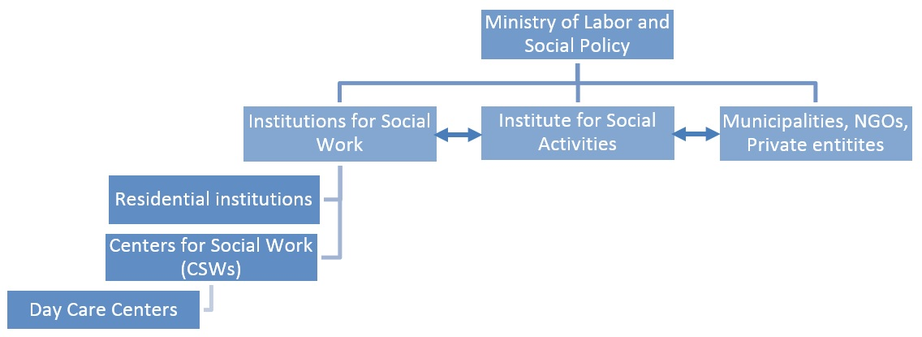

Although the total number of employees increased from 739 in 2006 to 1057 in 2013, 78 per cent out of 318 newly employed are administrative or other non-professional staff. In addition, the main occupation of professional staff is administration of the social assistance benefits, a heavy bureaucratic process of collecting and processing documents.

THE PROGRAMME

UNICEF supported the introduction of a comprehensive Training program for continuous professional development (hereinafter: the Training program) of social protection professionals, as part of a wider effort to reform the country’s social and child protection systems. In addition to work done on the Training program, UNICEF supported the MoLSP, ISA and CSWs in the introduction of standards for work, licencing of social work and the establishment of an electronic database of social services. UNICEF supported the reform at different levels – provided policy advice and technical assistance to key legislation reforms, capacity development for improving quality of service and used exchange of experience with other countries to move forward the reform agenda.

In 2007, UNICEF commissioned an Assessment of the Child Protection System. The assessment showed that the reform focused only on the expansion of the mandate of CSWs and the introduction of new responsibilities for CSW staff.

In the period between 2005 and 2009, UNICEF actively supported ISA to perform one of its key functions: to build the knowledge and strengthen human capacities to improve the quality of services delivered to children. It involved support to organize and deliver training of CSW staff, staff working in public institutions for children, staff from MoLSP and ISA. The trainings varied from training on street children, domestic violence, children with disabilities to children in conflict with the law, children without parental care etc.

In 2009, UNICEF contracted a national institute to conduct an external training impact evaluation. The purpose of the evaluation was to review the planning and implementation of the ISA training program and to make recommendations for improvements. It looked at the trainings delivered by ISA in a period of 5 years (2005-2009). The general finding of the evaluation was that the trainings were relevant, necessary and informative for most participants. Despite some positive effects highlighted above, most participants believed that their services for children is the same as five years ago. The evaluation also revealed that there is:

- Lack of written procedures for managing training;
- Lack of good documentation of training activities (which does exist in ISA, but is not systematically archived for easy access of those who might need these materials);
- Lack of monitoring and follow up on individual development of the trainees (from records of participations in various training sessions, to evaluation of the application of knowledge in practice).
- well-organized trainings and good dissemination of materials, but poor transfer of knowledge from one staff to another. The effectiveness is also reduced due to the frequent turn-over and transfer of staff. These transfers are particularly affecting the sustainability of training programmes.

In order to initiate the development and implementation of a comprehensive Training Program for social protection staff, in 2011 UNICEF conducted a comprehensive Training Needs Analysis targeting ISA, CSW and staff working in residential institutions. The assessment led to the identification of a number of shortcoming and bottlenecks in the six main areas subject of inquiry: planning, delivery, documentation, relevance, efficiency, effectiveness and longer-term impact. For more details on the main issues identified, please see annex 2.

UNICEF contracted Westwater International Partnerships and the University of Strathclyde to build on the findings of the Training Needs Analysis and develop: (i) an in-service training curriculum targeting CSW and ISA staff including the public child care institutions, ii) training tools and training manual, iii) tools for monitoring learning achievement of trainees and iv) training for ISA staff on how to use the training tools including the learning achievements tools. As a result, a training program was devised to help staff have a clear and helpful path for their continuing professional development. The program was also developed to contribute to the issuing and renewal of licenses for professionals working in social protection. The training program is consisted of six core modules and eight selective modules (see table below), with corresponding training material. The material in each core module takes one day to deliver. Then each participant attends a half day recall session, which is held three months after the training day. During the recall session, staff is expected to present the evidence they have collected to prove their competence in this module. In addition, professionals can undertake a further two specialist modules which are specific to their areas of work (See annex 3).

Currently, all 845 licenced professionals in social work (social workers, lawyers, psychologists, pedagogues, special educators, etc.) in the country have passed the ISA Training Program.

The general theory of change underpinning UNICEF’s engagement in the design and delivery of the Training Program was that ensuring children in need have access to quality social protection services will facilitate access to a minimum standard of living, nutrition, education and adequate care. All children and their carers in need must access an adequate mix of cash assistance and social support services, regardless of sex, age, disability, and other circumstances. As such, the overall objective of UNICEF’s engagement in the design and delivery of the Training Program was to increase the quality of social protection services by building the capacities of social protection staff to deliver on them.

The main assumption on the objective was that through the proposed intervention, social protection staff will be sufficiently willing to participate in the new concept of continuous professional development, adjusted to the ever-changing social environment. Managers in Centres for Social Work will promote learning and development among their staff. A legal and policy framework will be developed to support the delivery of continuous professional development. The main risk related to the objective of this work related to the high turnover of staff (both in management and service delivery positions) and inability to ensure continuum in support.

RATIONALE

The UNICEF country office will conduct an evaluation with the purpose of assessing the results of UNICEF’s support in the development and implementation of the ISA Training Program for continuous professional development of social protection professionals. It will also measure the extent to which the Training Program addressed major bottlenecks in improving access to social protection for vulnerable children, and reduced equity gaps.

The evaluation is undertaken after five years of UNICEF’s active involvement in supporting ISA and the Government in the development and roll-out of the Training Program. Given the context, the evaluation is planned to have a summative purpose. The knowledge generated by the evaluation will be used by the Government and UNICEF to inform the planning and implementation of the new country programme 2016-2020.

UNICEF will ensure dissemination of evaluation findings and recommendations to the following partners:
- MoLSP, as a main partner and the responsible ministry for social protection to inform future planning, budgeting, guidance and support, inspection, monitoring and evaluation of the reform;
- ISA, the responsible institution for data collection, setting standards, monitoring and supervision of CSW work, in-service training. ISA will use the evaluation results to learn about approaches –what works, what doesn’t work and how can ISA support to CSW staff be further improved to ensure best support for young children and inclusion of the most marginalized groups.

Morover, UNICEF will invite relevant representatives from the MoLSP and ISA to review the outputs of the evaluation within an appropriate reference group.

OBJECTIVE

The main objective of the evaluation of the ISA Training Programme is to provide evidence of the impact and the results achieved by ISA and the Training Programme, identify bottlenecks and barriers in implementation and provide recommendations for future activities. Therefore, the objectives of the evaluation are to:

- Assess the relevance, efficiency, effectiveness, sustainability and to the extent possible impact of the ISA Training Programme;
- Identify and document lessons learned and the contribution of UNICEF to these systems or impact changes; and
- Provide recommendations to guide UNICEF involvement in supporting and/or upgrading the ISA Training Programme for social protection staff.

SCOPE AND LIMITATIONS

The evaluation will focus on the UNICEF supported training programme implemented by ISA in the period between 2011 and 2016. The geographical coverage will include both national and local levels.

The evaluation will be based on a desk review, interviews with key interviews and focus group discussions with all involved stakeholders. At national level, the evaluation team should meet with representatives of the MoLSP, ISA, the Committee for licencing social workers and other partners/donors (i.e. GIZ, the World Bank, etc.). At local level, the evaluation team should meet with representatives of CSW staff, care institutions for children, end-beneficiaries, CSOs and academia representatives. The programme has a strong component focusing on capacity building and improving the quality of services. Therefore, the evaluation should pay particular attention to this component.

One of the possible limitations is the high staff turn-over. Therefore, the assessment of the impact of capacity building activities might be affected. In addition, the questions related to impact on children may be limited to the impact at system level. The changes in life of children will not be a subject of this evaluation because baseline data on situation with life of children is not available therefore no comparison with current situation is possible. Moreover, no children will be interviewed as part of the work on this assignment.

The Human Rights Based Approach (HRBA), equity and gender equality and mainstreaming will also be subject of assessment.

QUESTIONS

The evaluation will assess ISA’s Training Programme and its contribution to raising the capacities of social protection professionals in CSWs and care institutions for children (good/bad practices, innovations and models as well as strategies that work and can be scaled up or replicated) in terms of their relevance to the child rights and equity agenda, effectiveness, efficiency and sustainability (as defined by OECD/DAC).

Relevance
- Has the Training Programme been aligned to governments and partners’ priorities/policies/reform agendas?
- Has the Training Programme (content and delivery) been aligned with the CRC principles (non-discrimination, best interest of the child, the right to life, participation), gender mainstreaming and Human Rights Based Approach (HRBA) to programming? Did it contributed towards gender mainstreaming and HRBA?
- To what extent are the by-laws, policies and other documents that regulate continuous professional development for social protection staff relevant for the reform process?
- How relevant and gender sensitive are the capacity building activities for professionals for CSW staff to deliver quality services to children in-line with the ISA Training Programme? and
- To what extent are the data collecting and monitoring activities for the delivery of the Training Programme relevant for the country context?

Efficiency
- Have UNICEF’s resources invested in the development and delivery of the Training Programme been used in the most efficient manner?
- Would there have been a more cost-effective way to achieve the expected results?
- Has the Training Programme been successful in leveraging governments’ political will and financial resources to address the social protection sector reform?
- How well the implementation of activities has been managed? What management and monitoring tools have been used and what tools could have been used?
- Did ISA ensure coordination with other similar programme interventions to encourage synergies and avoid overlap?
- What strategies/core roles of UNICEF (see annex 1) have been most efficient in influencing improvements in the continuous professional development for social protection staff?

Effectiveness
- Have the planned results been achieved (quantitative and qualitative)?
- To what extent the design and delivery of the Training Programme contributed to strengthening monitoring and reporting capacities in the social protection sector?
- How successful was the Training Programme in establishing and developing the national level mechanism for continuous professional development of social protection staff?
- To what extent the Training Programme contributed to building the capacities of the CSW staff to provide services to children, and what are the options or possibilities for expanding and scaling?
- Has the Training Programme provided any additional (not directly planned) significant contribution or outcome in the social protection sector?
- To what extent was the design and delivery of the Training Programme successful in reducing gender-based differences?
- What factors affected the Training Programme’s successes and failures?

Impact
- How successful was the Training Programme in improving the practice and quality of services provided by CSW staff to children at risk?

Sustainability
- What is the likelihood to achieve sustainability for the ISA Training Programme without UNICEF support?
- What would be the transformed engagement of UNICEF in part of exercising its Core Roles (see annex 1) in the future?
- Did the design and delivery of ISA’s Training Programme promote ownership among relevant partners?

Issues related to the Human Rights-Based Approach to Programming, Results-Based Management and Gender Equality will be addressed across the evaluation questions or, if required, developed as specific points as per United nations Evaluation Group (UNEG) Guidance on Integrating human-rights and gender equality in evaluation (see link below) and complies with the organization’s commitment to gender mainstreaming as expressed in the Policy on Gender Equality and the Empowerment of Girls (http://www.uneval.org/documentdownload?doc_id=980&file_id=1294).

Evaluation questions will be further refined and additional ones will be incorporated by the Evaluation Team – if required - during the inception phase.

METHODOLOGY

The evaluation will follow internationally agreed evaluation criteria of relevance, efficiency, effectiveness, impact, and sustainability. Stakeholders will participate in the evaluation through discussions, consultations, provide comments on draft documents and some of them will be responsible for follow-up to the recommendations.

To ensure impartiality and lack of biases, the methodology will include a cross-section of information sources (e.g. stakeholder groups, including beneficiaries, etc.) and a mix of quantitative, qualitative, participatory methodology to ensure triangulation of information.

The evaluation will be based on analysis of secondary data and on primary data collection. Secondary data will be assessed during the pre-mission phase to start addressing evaluation issues and identifying the information gaps prior to the in-country mission.

Inception Phase: The first step of the evaluation process will be the inception phase during which the Evaluation Team will develop an evaluation framework based on the TOR. For each of the questions and sub-questions, the evaluation team will develop indicators to inform the responses and identify the corresponding means of verification. The inception phase will be used to better define the scope and the methodology of the evaluation. On that basis, the team will develop a detailed methodology based on the key elements identified above. In addition, the Evaluation Team will assess potential limitations to the evaluation work and in particular the availability and reliability of data. The Inception report will also include proposed methodology and guidelines for development of case studies. The case studies should capture the change in practices of social protection staff as a result of UNICEF supported interventions.

A Desk Review will be undertaken of evidence available at country level in relation to the impact and results of ISA’s Training Programme. The desk review will rely on UNICEF documentation (assessments, evaluation and reports), but will also cover government documents, including ISA programme implementation reports, assessments, studies, policy documents, strategy papers, plans of action, evaluations and documentation of projects implemented by other partners. Administrative data or other available data sources will be verified and analysed to confirm system level results.

In-country data collection: primary data collection will include information from interviews with key informants and/or Focus Group Discussions (FGDs) with key stakeholders (MLSP, ISA, CSWs, care institutions for children, municipalities, NGOs, academics) and questionnaires for CSW staff that will aim to collect both quantitative and qualitative data.

Data analysis and report writing: the process will start at the inception phase when the evaluation team will propose detailed methodological approach and the structure of the final report. Data analysis will progress simultaneously with the desk review and the in-country data collection. The draft final report will be reviewed by UNICEF Skopje. The Evaluation team will incorporate the comments and submit the Final report to UNICEF Skopje.

General considerations: The methodology of the evaluation will be in line with the United Nations Evaluation Group (UNEG) Norms and Standards.

AVAILABILITY OF DATA/INFORMATION SOURCE

The data and information source listed below are coming from official state institutions or UNICEF produced report. Therefore they are considered reliable and of sufficient quality.

The State Statistics Office issues annual reports on users of social services. The data provided in the reports is disaggregated by gender, ethnicity, age, municipality (as appropriate).

The TRANSMONEE database contains child related data on national level. The database is updated annually by the State Statistic Office.

The CSW operate an electronic data system LIRIKUS for all services provided to children. Using this system, the Institute for Social Activities can generate national and local level data.

Other reliable sources of information are available from UNICEF:

- 2010 ISA Training Impact Evaluation
- 2011 ISA Training Need Assessment
- 2011 A situation and gap analysis related to CSW standards and procedures
- ISA Annual Reports
- 2013 UNICEF Situation Analysis of girls and boys in the former Yugoslav Republic of Macedonia

WORK PLAN

13 June Review of ToR within Country Office
20 June Review of ToR by Regional CP, M&E advisors and the UNIVERSALIA
18 July Publish ToR – with deadline for application 19 August
02 September Selection of consultant/s (international and national)
10 October Inception report
30 October In-country mission
30 November Draft evaluation report
20 December Final evaluation report

TEAM COMPOSITION

The evaluation team will consist of one international and one national consultant.

The competencies required from the international consultant are the following:
- Advanced degree in law, social sciences, political sciences or related fields;
- At least 8 years of professional experience in conducting evaluations;
- At least 5 years of experience on reforming social protection sector programmes;
- Ability to work in an international environment;
- Previous experience of working in CEE&CIS countries an asset;
- Excellent analytical and report writing skills;
- Familiarity with UNICEF’s mission and mandate an asset;
- Expertise on gender equality and child rights will be considered an asset;
- Excellent mastery of English.

The competencies required for the national consultant are the following:
- BA degree in law, social sciences, political sciences or related fields;
- At least 3 years of professional experience in conducting evaluations;
- At least 2 years of experience on reforming social protection sector programmes;
- Ability to work in an international environment;
- Experience in work in multi-ethnic/multi-language environment;
- Excellent analytical and report writing skills;
- Familiarity with UNICEF’s mission and mandate an asset;
- Expertise on gender equality and child rights will be considered an asset;
- Mastery of English and Macedonian.

EVALUATION MANAGEMENT

The Evaluation will be led by the UNICEF Country Office. The Evaluation Committee (composed of Deputy Representative, Social Protection Specialist and Monitoring and Evaluation Specialist) will provide a general oversight on the evaluation work. The Social Protection Specialist and the Monitoring and Evaluation Specialist will provide technical advice and supervision to the external evaluation team. The UNICEF Country Office together with national partners will be responsible for organizing the field visits, meetings, consultations and interviews, for providing access to the government counterparts, donors and partners, and for coordinating the work at country level with other stakeholders.

The Regional Monitoring and Evaluation Advisor will provide support to ensure that the evaluation process is in line with the regional evaluation guidance.

The external Evaluation Team that will be hired to conduct the evaluation will be responsible for conducting the desk review for the assignment, organizing the technical preparation of the field visits, undertaking the country visits and producing the deliverables, i.e. inception report, evaluation methodology, sample, instruments and questionnaires, draft and final evaluation reports. While it is not expected that vulnerable children will be requested to participate in the evaluation, the Evaluation Team will ensure that the evaluation process is ethical, in line with UNEG Ethical Guidelines, UNEG Norms and Standards.

PRODUCTS TO BE DELIVERED and STRUCTURE OF EVALUATION REPORT

The evaluation report to be produced must be compliant with the UNICEF Evaluation report standards: http://intranet.unicef.org/epp/evalsite.nsf/0/2BDF97BB3F789849852577E500680BF6/$FILE/UNEG_UNICEF%20Eval%20Report%20Standards.pdf and the GEROS Quality Assessment System.

The deliverables will include:
- The Inception Report, and
- The Evaluation Report.

Following is the proposed structure for the inception and evaluation report.

Structure of the Inception Report
- Response to the TOR Evaluation
- Framework
- Methodology
- Potential limitations of the evaluation according to data availability and reliability

Structure of the Evaluation Report (Tentative)
- Title Page
- Table of content
- List of Acronyms
- Executive Summary Object of the Evaluation
- Acknowledgements
- Evaluation Purpose, Objectives and Scope Evaluation Methodology
- Findings
- Conclusions and Lessons Learned
- Recommendations
- Case Studies
- Annex

The structure of the final report will be further discussed with the Evaluation Team (during the Inception Phase).

RESOURCES AND PAYMENT SCHEDULE

Cost category | Cost description | Total, USD
International (evaluation expert)  7 days – Desk review and Inception Report  7 days – Field work  7 days – Draft report  3 days – Final Evaluation Report | 24 days x 500 | 12,000
National  7 days – support to preparation of Inception Report  7 days – Field work  5 days – Draft report  5 days – development of case studies | 24 days x 300 | 7,200
Travel (ticket) |  | ~ 2,000
Travel (DSA) |  | ~ 900
Terminal expenses |  | 300
TOTAL |  | 22,400
Payment shall be made as follows:
- 40% will be paid upon submission of the Inception report
- 60% will be paid upon submission of the final report

The UNICEF CO will provide interpreters during the in-county visits. The evaluators will be provided with office space, vehicles for site visits and official meetings, logistical support for meeting and visa procedures. Laptops or computers will not be provided.

REMARKS AND RESERVATIONS

UNICEF reserves the right to withhold all or a portion of payment if performance is unsatisfactory, if work/deliverables are incomplete, not delivered or for failure to meet deadlines.
All material developed will remain the copyright of UNICEF. Evaluators are responsible for their performance and products. UNICEF reserves the copyrights and the products cannot be published or disseminated without prior permission of UNICEF.

Candidates interested in the consultancy should submit a proposal with approximate methodological proposal, estimated costs, time line, and resume of the evaluators who will take part in evaluation process.

 | Name and Title | Date | Signature
Prepared by: | Aleksandar Lazovski, Social Protection Specialist
Cleared by: | Rajae Msefer Berrada, Deputy Representative
Approved by: | Dr. Bertrand Desmoulins, Representative

Annex 1 UNICEF Core Roles

UNICEF plays a key role supporting changes in the system conducive of reduction of equity gaps and child rights violations. There is consensus that the following Core Roles are indispensable for a sustainable UNICEF engagement and its universal presence in support of results and the realization of the rights of children everywhere:

- The ‘Voice’ for children and adolescents -- advocating and communicating around key national policies, social issues, mind-sets and attitudes;
- Monitoring and evaluation – assisting independent assessments of the functioning of the Child Rights guarantee systems, the progressive realisation of child rights and the reduction in equity gaps in child well-being;
- Policy advice and technical assistance – through well-designed UNICEF positions (based on local, regional, international best practices) on key issues, supporting the development of the normative frameworks related to specific national legislation, policy or programme as well as private sector standards that can improve equity;
- Leveraging resources from the public and private sectors – accompanying and redirecting reforms, including those supported by the EU, IFIs, bilaterals and national/multi-national corporations;
- Facilitating national dialogue towards child friendly social norms – bringing together government, private sector and civil society, as well as convening divergent forces to enhance public debate, participation and action around equity and child rights;
- Enabling knowledge exchange – fostering horizontal cooperation and exchange of experience among countries and regions on ‘what works’ for enhancing child well-being and equity.
- modeling/piloting demonstrating how system could meaningfully evolve to reduce equity gaps and children’s rights violations

Annex 2: Main issues identified in the 2011 Training Needs Analysis targeting ISA, CSW and staff working in residential institutions

Area of Inquiry | Main issues | Possible Solutions
Planning | Participants in trainings have little involvement in its planning. | Ensure that training participants have more involvement in planning. This should include professionals within the CSWs and residential institutions in offering suggestions.
Planning | At the moment, training plans are drawn up by ISA on an annual basis. In addition, a wide range of NGOs offer training courses. | Move to a longer term training plan, which would allow a more systematic coverage of core areas of knowledge.
Delivery | There is a wealth of experience and knowledge in the CSWs and residential institutions. | There is a need to address the question of how to capture, distil and disseminate the wealth of skills, experience and expertise that already exists.
Delivery | There is no apparent system for transfer of knowledge gained during training events and post-training discussions with colleagues. | There is room for improvement in the area of transfer of knowledge
Documentation | There are no mechanisms for recording the ongoing development of workers. | A system of one-to-one workplace review needs to be implemented.
Documentation | No system for the accreditation of training. No standards for training. No agreed curriculum. | Develop curriculum and a set of standards.
Relevance | Available training material is not directly relevant to the workers’ specific needs | Use more experiential training methods utilising case studies and vignettes.
Relevance | The pre-service professional training for social workers has an inadequate pre-service placement period. | Any in-service training should take account of this.
Efficiency | Often, different NGOs offer the same training, yet each training event may have a different message and not be entirely relevant for everyone who attends | A systematic method of approving/commissioning external training providers and linking this to the curriculum and standards will be required.
Efficiency | There is no apparent process for the selection of participants for the trainings | Transparent individual development plans should be developed and linked to organizational needs.
Effectiveness | There is no mechanism for responding to feedback and suggestions from training events. | Remarks from participants should be systematically recorded and acted upon in a goal-oriented manner.
Effectiveness | There is no system in place to see how material learned during training has impact on practice. | An assessment structure which relies on the use of practice examples could help to address this.

Annex 3: ISA Training Program list of core and specialized modules

No. | Type of Module | Module Name
1 | Core | Promote equality and value diversity of people
2 | Core | Communicating with people
3 | Core | Understanding the needs and working with at-risk children
4 | Core | Engaging with families
5 | Core | Engaging with communities
6 | Core | Reflecting on the practice of using one-to-one review and personal development planning
7 | Specialized (aimed at professional staff in care institutions) | Planning and implementing therapeutic activities
8 | Specialized (aimed at professional staff in care institutions) | Social group work
9 | Specialized (aimed at CSW staff) | Care management
10 | Specialized (aimed at CSW staff) | Assessing the needs of beneficiaries
11 | Specialized (aimed at managers) | Managing one-to-one review and continuous professional development
12 | Specialized (aimed at managers) | Social protection management skills
13 | Specialized (aimed at ISA staff) | Planning, managing and monitoring continuous professional development
14 | Specialized (aimed at ISA staff) | Delivering learning and development

Annex 4: Regional Theory of Change Diagram for Social Protection

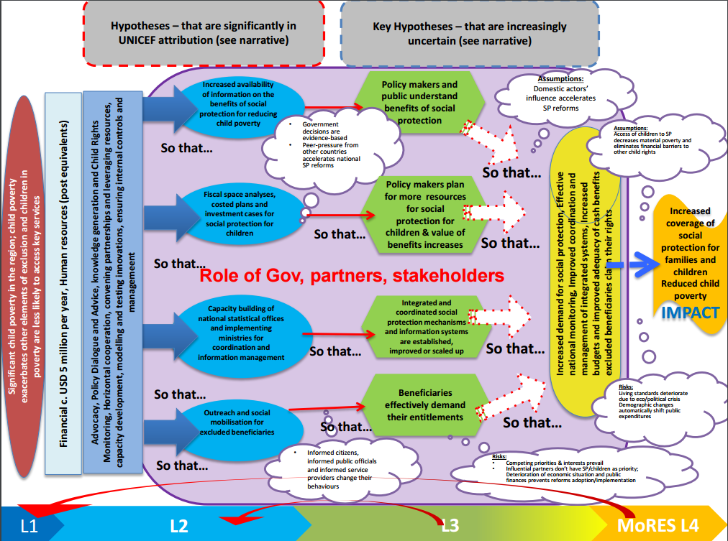

Source: UNICEF CEE/CIS Regional Knowledge and Leadership Area 8: A child’s right to social protection; Regional Strategy 2016-2020; February 2016

SSO, Laeken poverty indicators in 2014, http://www.stat.gov.mk/pdf/2015/4.1.15.100.pdf
SSO, Active Population in the Republic of Macedonia, Results from the Labor Force Survey, III quarter 2014, http://www.stat.gov.mk/pdf/2014/2.1.14.34.pdf
SSO, Laeken poverty indicators in 2014, http://www.stat.gov.mk/pdf/2015/4.1.15.100.pdf
A graphic representation of the regional Theory of Change for social protection is included as annex to this ToR.
http://www.oecd.org/dac/
Regional Knowledge and Leadership Agenda Generic Theory of Change underlying UNICEF’s approach in CEE/CIS Region, January 2013

