UNICEF Evaluation Brief
No. 2023/X
March 2023

Formative Evaluation of Thailand's Ministry of Public Health and UNICEF 'Pilot Child Protection Joint Initiatives 2018-2022'

All children everywhere have a fundamental right to be protected from violence, abuse, exploitation and neglect. Thailand's Ministry of Public Health (MoPH) and the United Nations Children's Fund (UNICEF) collaborated to test innovative models for preventive and responsive child protection services in pursuit of this goal. The pilot involved analyzing 'big data' from the health information system (HIS) using a new platform called Child Shield to identify children and families at risk of violence, and to case manage children identified as victims using the Primero information management platform. The partners also tested a Parenting for Lifelong Health (PLH) parent education programme as a violence prevention measure.
Primero™ is an open-source software platform that helps social services, humanitarian and development workers manage protection-related data, with tools that facilitate case management, incident monitoring and family tracing and reunification.
https://www.primero.org/

The evaluation objectives
MoPH and UNICEF commissioned an evaluation to reflect
on the progress and lessons learned from the experience of the
pilot Child Protection Joint Initiatives (CP Joint Initiatives) to
document successes and identify areas that need improvement
(Figure 1).

Figure 1. Objectives of the evaluation
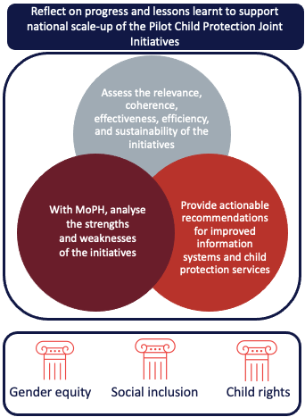
Child Shield was designed to utilise big data and artificial intelligence for real time and timely screening of at-risk children and families and track cases identified as high risk.

Figure 2. Location of the pilot CP Joint Initiatives
What are the CP Joint Initiatives?
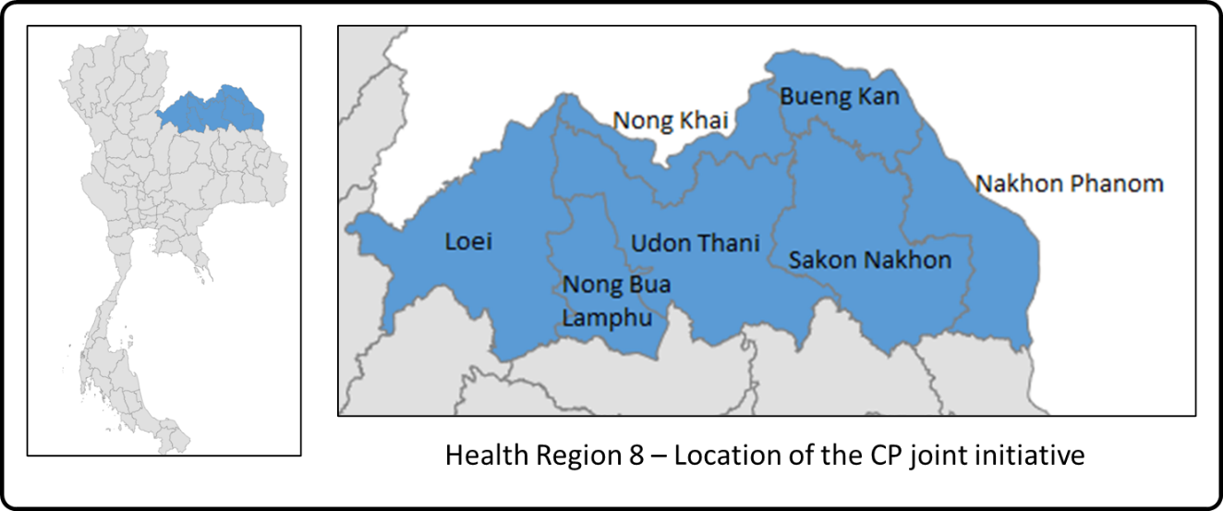

The CP Joint Initiatives were piloted in all seven provinces under Health Region 8 (Figure 2). The theory of change (ToC) was constructed retroactively for this evaluation based on documentation and discussions with UNICEF (Figure 3). This ToC hypothesized that if three inputs are integrated:
- The Child Shield information management platform analyses HIS data and identifies children and families at high, medium, low, or no risk of violence, exploitation, abuse, and neglect;
and
- as a violence prevention measure, families of children where risk is confirmed are enrolled in an accessible-to-everyone PLH parent education programme;
and
- children at high risk of exposure to violence are visited by a MoPH One Stop Crisis Centre (OSCC) worker who confirms the risk level. OSCC workers use Child Shield as a case management and tracking tool for children considered at high risk, and the Primero information management platform as the tool for case managing children confirmed as victims of violence.

Then several outputs will occur such that children and families in Health Region 8 will benefit from violence prevention and response services.
As a result, several intermediate outcomes are achieved that, if extended nationally, mean all children at risk of violence and their families will benefit from preventive and responsive child protection services provided by a capacitated and coordinated workforce.
Thus contributing to the realization of UNICEF's long-term outcome 'By 2026, more children, especially the most vulnerable, are better protected from violence, exploitation, neglect and abuse'.
Figure 3. Child Protection Joint Initiatives Theory of Change
What are the CP Joint Initiatives?
ves
Protection Joint Initiatives?
What are the results?

?
It is complex to report on the extent to which the CP Joint Initiatives have achieved their expected outcomes because the pilot programme architecture (ToC, results framework, monitoring and evaluation plan etc.) was not formally established in a written document at the outset. Nevertheless, the four-year pilot demonstrates some direct benefits for children exposed to child protection risk (Figure 4).

Figure 4. The effectiveness of the Child Protection Joint Initiatives
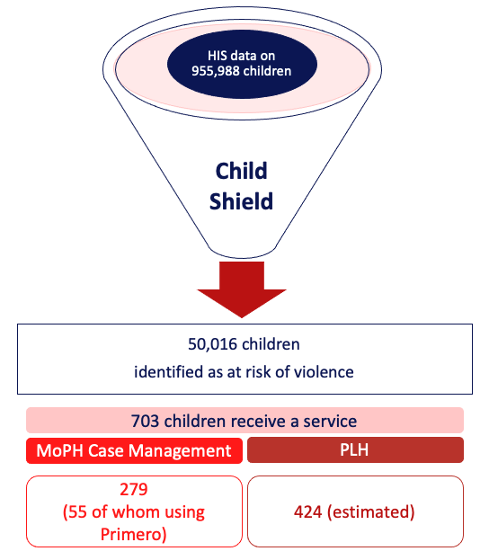
The evaluation found that Child Shield made innovative use of routine HIS data to improve its decision-making. However, the ambitious vision for the CP Joint Initiatives – that the analysis of 'big data' can identify child protection risks such that targeted interventions can prevent and respond to violence – has not been fully realized. This is partly because the Child Shield screening and calculation tool is not running as an automated and centralized server process but still relies on manual process intervention. As a result, only partial datasets are run, which introduces integrity issues.
What are the results?

?
At the same time, because they rely solely on HIS data, variables used by the platform are still not fully sensitive to child protection risk. As a result, less than 5% of children screened are identified as at risk, significantly below the estimated regional average of 50% exposed to violence. Additionally, less than 1% of children identified as at risk are actively followed up and case-managed because there is a lack of confidence in the system and because there are too few practitioners. Slightly more boys than girls are identified as at risk. This tallies with global data that indicates boys are more likely to experience physical violence than girls, thus, more likely to present to the hospital with an injury. In contrast, girls are more exposed to sexual violence, which is under-reported and, therefore, less visible in HIS data. Neither is the platform sensitive to the needs of children with disabilities, who comprise less than 0.16% of all children identified as at risk, despite being one-third more likely than their peers without disabilities to be subject to violence.
Identifying children at risk of violence using Child Shield without providing services could result in adverse consequences. Only 279 of the children identified at risk are being case managed. And of these, only 55 use the Primero information management platform because the MoPH already has a mechanism for case management linked to its monitoring system. There has been a missed opportunity to integrate the MoPH OSCC case management mechanism, the Ministry of Social Development Human Security (MSDHS) Child Protection Information System (CPIS), and the Primero platform to create an effective and efficient multi-sectoral case management mechanism that can reach more children.
The PLH programme has undergone a separate formative evaluation and randomized control trial showing its positive effect on violence reduction. Parents and professionals value the programme, and it has the most potential for providing direct benefits for children in the future. However, during this pilot, Child Shield at-risk status did not necessarily determine access to PLH as a violence prevention mechanism.
Overall there is not enough evidence to indicate the presence of a scalable model of child protection prevention and response.
Results-based management (RBM) is essential for effective programme design and delivery. Evidence-based planning, robust articulation of intended outcomes with appropriate indicators and systematic monitoring are fundamental to a programme's success. In particular, when planning a pilot programme or testing a model for eventual scale-up, the proof-of-concept requirements should be considered at the design stage.
Lessons Learned
Paying closer attention to the 'must-haves' to take a child protection prevention and response mechanism to a system-wide scale will contribute to improved results for children. In the case of the CP Joint Initiatives, for example, this would have involved an assessment of the potential for integrated multidisciplinary child protection systems for prevention and response.
Key Recommendations
Embed continued support for the CP Joint Initiatives in a systems-strengthening approach, matched to a robust results framework and M&E plan jointly designed by UNICEF and MoPH.
Make the CP Joint Initiatives part of the dialogue on the government's ongoing national multi-sectoral child protection system to create a plan for seamless cooperation and collaboration across sectoral ministries on child protection.
Increase UNICEF's internal coherence on PLH by integrating UNICEF Country Programme Outcomes on Early Childhood Development (Outcome 1), Young People (Outcome 3), and Child Protection (Outcome 4).
Identify a partner for developing a longer-term strategy for systematic multi-sectoral PLH roll-out.
Fully implement UNICEF Thailand's recently introduced Guidelines for Scale-up Models and Pilots to improve the efficiency and long-term sustainability of innovative child protection programmes.
Consider the benefits of conducting an institutional capacity assessment, which is fundamental to understanding how innovations in child protection systems development can be introduced and sustained.
Consider advocating and providing support for the integration of Primero with (i) internal MoPH databases managed by OSCC and (ii) MSDHS's CPIS.
Review and, where necessary, adjust internal UNICEF programme documentation, paying explicit attention to the equitable community inclusion of children with disabilities and women and girls.
Next steps

This brief is based on the comprehensive Formative Evaluation of Thailand's Ministry of Public Health and UNICEF 'Pilot Child Protection Joint Initiatives 2018-2022', implemented by Oxford Policy Management Ltd (OPM), on behalf of UNICEF.

McCoy, A., Lachman, J.M., Ward, C.L. et al. Feasibility pilot of an adapted parenting program embedded within the Thai public health system. BMC Public Health 21, 1009 (2021). https://doi.org/10.1186/s12889-021-11081-4
UNICEF Thailand Country Programme, March 2022 – December 2026, Outcome 4
Hillis, S., Mercy, J., Amobi, A. and Kress, H. (2016) ‘Global Prevalence of Past-year Violence Against Children: A Systematic Review and Minimum Estimates’, Pediatrics 137(3), p. e20154079. 10.1542/peds.2015-4079 https://publications.aap.org/pediatrics/article-abstract/137/3/e20154079/81439/Global-Prevalence-of-Past-year-Violence-Against?redirectedFrom=fulltext
Phillips, J. and Vandenbroek, P. (2014) Domestic, family and sexual violence in Australia: an overview of the issues. Parliament of Australia. https://www.aph.gov.au/About_Parliament/Parliamentary_Departments/Parliamentary_Library/pubs/rp/rp1415/ViolenceAust
UNICEF, September 2021, Child Protection Systems Strengthening. Approach, Benchmarks, Interventions. UNICEF: New York https://www.unicef.org/media/110876/file/Child%20Protection%20Systems%20Strengthening%20.pdf

