

United Nations Children’s Fund

Human Resources

TERMS OF REFERENCE FOR CONSULTANTS AND INDIVIDUAL CONTRACTORS
Title | Individual consultancy: Supporting ECAR country offices with pilots and modelling for scale up (3 consultants)
Purpose | The processes of piloting and modelling are a key strategy of UNICEF within the Europe and Central Asia (ECA) region. Piloting is defined by UNICEF as testing a new theory of change to assess whether an approach could be effective. Modelling is defined as demonstrating that the intervention works in a new context, to promote replication and encourage adoption by others. Several country offices in ECA region are implementing project models and pilots and need support with the modelling work with the view of scale up. ECARO is seeking to hire 3 individual consultants to help ECARO and COs with such types of work on demand and needs-based basis.
Location | Home-based
Duration | May – December 2021
Reporting to | Dual reporting line: UNICEF Evaluation Specialist, Saltanat Rasulova and UNICEF Regional Evaluation Advisor, Mirella Hernani

Background and Context

The processes of piloting and modelling are a key strategy of UNICEF within the Europe and Central Asia (ECA) region. Piloting is defined by UNICEF as testing a new theory of change to assess whether an approach could be effective. Modelling is defined as demonstrating that the intervention works in a new context, to promote replication and encourage adoption by others. In practice, it is found that these stages (piloting vs modelling) are not distinguished from each other, and the early work to develop and test programmes is regarded by the UNICEF teams as part of modelling (UNICEF 2020). Models are implemented on the ground to create evidence and engage local partners to identify solutions for children to be replicated or scaled up. Although there is no widely agreed definition of ‘scale’, there is clarity in what ‘scaling’ or implementing at scale means i.e. “To support the widespread replication and/or adaptation of an innovation across large geographies and populations for transformational impact.” (IDIA, 2017 in UNICEF 2019).

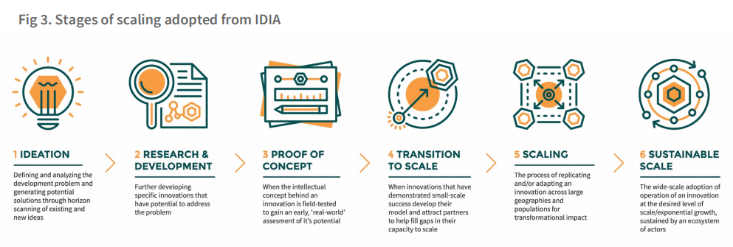
Source: UNICEF (2019)

In 2014 UNICEF developed consensus about the necessary conditions for modelling, based on discussions between Deputy Representatives in all Country Offices (CO) and the Regional Office of the Central and Eastern Europe and Commonwealth of Independent States region. UNICEF have launched a significant number of models between 2016-2020 in the areas of health, child protection, education and adolescent wellbeing. The process of modelling is intended to provide information about the effectiveness and feasibility of wide-scale implementation, and to be an advocacy tool in efforts to secure the resources and partnerships need for scale up and sustainability of the models. It intends to proof that a concept or components of an intervention works or does not in certain circumstances and intends to fine-tune implementation to eliminate bottlenecks and reach the intervention’s goal. It is also intended to increase ownership and buy-in from stakeholders.

At the moment, embedding evidence throughout implementation is at the core of an effective adaptive management strategy that ECAR is adopting.
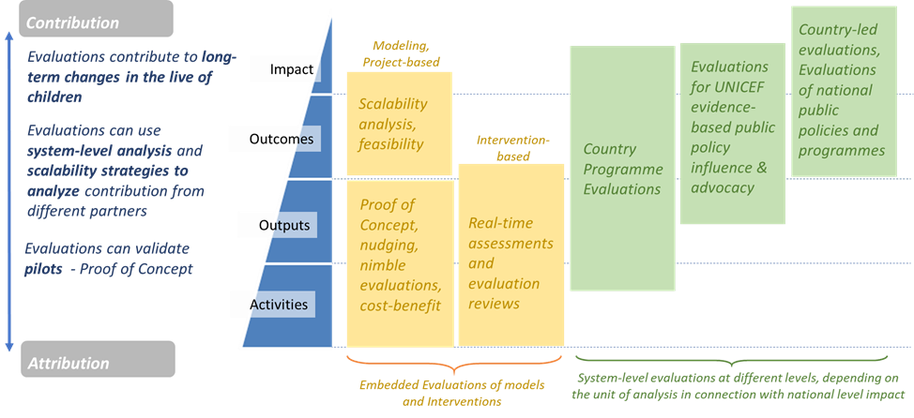

This type of work is evident in modelling and assessments of interventions that require an agile reflection and decision-making processes that affect primarily implementation of programme outputs. The evaluative work is delivered throughout the implementation process and not at the end of implementation. New developments in technology and data analytics make the evaluability efforts of modelling work more dynamic, less costly, and allows for multi-variable analysis of information in a quick manner.

This line of work has not yet been explored much. It requires a shift of culture and operation and can be implemented in various ways. There are currently several pilots and models one of which is the EU4Moldova project in Moldova conducted by the UNICEF Country Office. The overall objective of the five-year programme is to strengthen the economic, territorial and social cohesion in the Republic of Moldova through facilitating inclusive, sustainable and integrated local socio-economic growth and improving the standards of living of children, adolescents and all citizens in the two focal regions Cahul and Ungheni (Annex A). The current assignment will start with this project and extend to and cover other additional pilots and models with an intention of scale up.

Purpose:

Under the supervision of the UNICEF regional advisor for evaluation and regional evaluation specialist, the consultant(s) will be responsible for providing ECAR Country Offices on demand support with designing and setting up their monitoring and evaluation (M&E) frameworks to ensure that the models and pilots are evaluable from the start and that there is reliable and rigorous data and evidence to demonstrate that these small scaled interventions have produced outputs, outcomes and are likely to contribute to the impact beyond the reasonable doubt. As part of this work the consultant(s) will help ECARO strengthen the internal UNICEF M&E landscape of the models and pilots. Before investing in a large-scale project, testing its assumptions on a smaller scale can help UNICEF ECAR to become better equipped to plan and execute for the larger scale deployment. UNICEF COs can reduce the risk of propagating mistakes by detecting errors at the pilot stage. Some pilots can be used to assess the impact of using the technology for service delivery. By showing what works and does not work at the small scale, the pilot can provide the evidence needed to secure more funding or to justify greater expenditure on specific areas. If needed, consultant(s) will provide an advisory role to the UNICEF COs in adaptive management of pilots and models.

Scope of work and key deliverables:

For the purpose of the assignment, consultant(s) will undertake the following tasks among others which can vary from case to case:

With Country Offices:
- Provide guidance and support to the COs starting from the project planning stage to ensure scalability elements are embedded in the project design and methodology from the very beginning (review of the ToR, calls for proposals, project documents etc.)
- Draft and further refine Theories of Change (ToC) and Results Framework for pilots and models together with UNICEF COs and implementing partners connecting local implementation, sub-national and national effects.
- Design and develop a monitoring and evaluation (M&E) system(s) which is based on the Theories of Change and Results Framework and further refine it after relevant consultations and tests. Such a system(s) (or framework) has to cover all the aspects of ToCs i.e. results, all types of assumptions, operational aspects of the pilots and models including financial aspects of the interventions (cost and benefit analysis). The system should therefore include targets relevant to the process of how pilots and models are implemented, how contextual factors are interplaying with the interventions and how much pilots and models cost and how resources are spent. The M&E system will generate evidence for advocacy purposes with governments and other development partners to enable scalability of pilots and models in different dimensions, including political willingness, financial commitment, assessments of capacity of institutions, M&E and connection with national statistical and administrative data systems.
- In case of complex initiatives with multiple components and implementing partners, help COs identify ‘scalable’ elements/projects/sub-projects.
- Ensure that M&E system(s) are in line with UNICEF RBM and PPPs practices and guidelines and are designed through equity and gender equality lenses and are also connected with higher level results for scalability (enabling environment for scaling).
- Ensure M&E systems are aligned with UNICEF planning, monitoring and reporting processes and procedures of UNICEF, but also of National Systems, including National or Sub-national Administrative Data Systems.
- Provide support to and interact with managers and implementing partners of pilots and models for the purposes of effective Knowledge Management in relation to planning, M&E, documenting of the results achieved for potential scaling up as well as good practices and lessons learned (as part of capacity building component).
- Make an initial implementation of M&E system(s) and train COs or/and government’s staff responsible for the monitoring to effectively implement it, as required (linked to national data system generation and also use for decision makers)
- Train UNICEF COs, implementing partners and RO staff on how to design, implement and monitor M&E system(s).
- Develop additional tools, templates, and activities contingent to the M&E system to fill in any data gaps and respond to any changes affecting the intervention, as required (including templates for documenting the implementation process).
- Design, lead or/and advise COs with establishing and conducting a baseline assessment (including guiding the sampling design, data analysis plan, data collection options, data analysis, and etc.), as required – throughout the whole ToC (local implementation “proof of concept” and scalability)
- Develop a plan for adaptive management and guide the implementation of adaptive management processes, as required.
- Any other tasks within the scope of this ToR as required
With the Regional Office:
- Document and share good practices and brainstorm with the RO on further improving modelling and piloting work in ECAR.
- Any other tasks within the scope of this ToR as required

Deliverables:

The following estimates are tentative | Time allocated
Draft and refined ToCs and results frameworks (approximately 4 of each) | On demand
Draft and final M&E system/framework (including above) (approximately 4) | On demand
Draft and refined adaptive management guides (approximately 4) | On demand
Additional templates, guidelines, checklist, rubrics, and etc. for better documenting and analysis | On demand
Any other ongoing support to COs and RO with relation to pilots and models on demand | On demand
Support to RO with analysing good practices | On demand
Capacity building of COs, implementing partners and RO | On demand
Contribution and participation in any events with CO, implementing partners and RO staff in relation to pilots and models | On demand

Qualifications and Experience Required

- Advanced university degree, preferably in evaluation, social studies or a related field. A combination of relevant academic background and relevant work experience may be accepted in lieu of the advanced university degree;
- At least ten years of experience in developing M&E systems, conducting evaluation, and research
- Proven experience in proof of concept evaluations, as well as scalability analysis and broad M&E systems with governments (preferably in ECA region)
- Strong familiarity with UNICEF and the UN system, and ECA region
- Experience in real-time evaluating application-based innovations and conducting evaluation experiments, nimble and/or impact evaluations, and behavioral science
- Demonstrated data collection and analysis skills.
- Demonstrated strong communication and interpersonal skills.
- Proficiency in English, Russian and any other language spoken in the region is required.
- Previous solid experience of designing and leading experimental and non-experimental research and evaluation.
- Familiarity with UNICEF procedures (possible but not necessary);
- Ability to produce content for high standard deliverables in English;

Estimated Duration of the Contract:

The contract will cover the period from May – December 2021.

Deliverables over the course of the assignment will be agreed on a monthly basis with the consultants’ supervisors and will be documented through monthly reports. Payments will be made against set deliverables
based on the agreed negotiated daily rate.

Work Place and Official Travel

The consultant will be home-based, preferably based in similar time zone as Geneva.

Prepared by: Saltanat Rasulova
Date: 7 April 2021

UNICEF (2021) Evaluation of Models for Scale-up Potential in Serbia 2016-2020: Final Report. March 2021 Prepared for UNICEF Country Office, Serbia
UNICEF (2019) Scaling Innovation for Ever Child
Ibid. p. 6

