7 December 2022
UNICEF ECARO evaluation team and UNICEF Belarus CO joint work on Child Rights Monitoring programme evaluability assessment in 2021 followed with the evaluation in 2022
This work is within the existing RO ToR and contract with Antonina Rishko-Porcescu on supporting COs with the evaluability of their projects
This is a simplified ToR for the evaluability assessment ONLY to take place during December 2021 – February 2022
Background
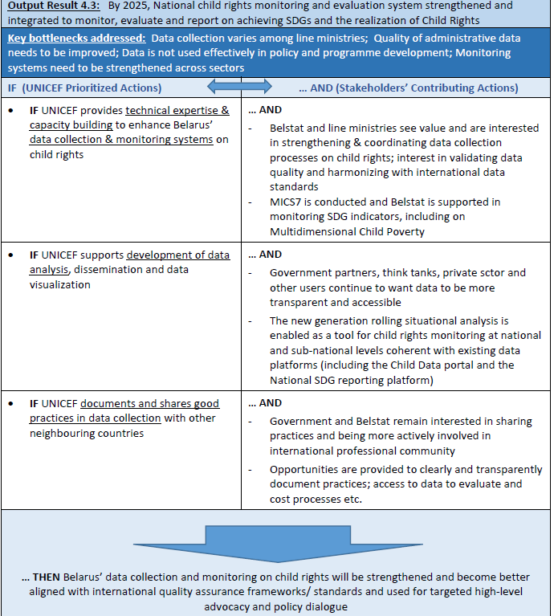
UNICEF has long been a recognized partner for Belstat and other institutions on child-related data and analysis. Important steps by Belstat have been made to enhance accessibility of data on child rights and SDGs, through the establishment of the Universal Data Portal on child-related statistics and SDG reporting platform which have been jointly designed with UNICEF. Nonetheless, data systems still need to be enhanced – at present Belarus collects and reports only on 41 out of 51 SDG indicators relevant to children. As reflected in the Strategic action plan on data for children investments for 2017-2021, the national child rights monitoring and evaluation system is in need of further strengthened to consistently monitor and report progress on the implementation of the Convention on the Rights of the Child. UNICEF has been providing technical assistance to and building the capacity of Belstat and national child protection authorities in reviewing procedures for the systematic collection, analysis and use of data, the validation of administrative data, harmonization of data across institutions, and dissemination. The aim is to enhance data coverage and alignment with international quality assurance frameworks with the main goal of strengthening the capacity of Belarus’s data collection and monitoring child rights and them becoming better aligned with international quality assurance framework/standards and used for targeted high level advocacy and policy dialogue.. This type of government support is conducted within UNICEF Child Rights Monitoring (CRM) Programme.
Child Rights Monitoring at UNICEF Belarus
Child Right Monitoring work is under outcome result 4, output result 4.3 of the current CPD 2021-25.
The intended results of outcome 4 are largely qualitative in nature, and there are few existing data collection systems that can be readily used. The component is mainly about bringing actors together, influencing Belarus with new ideas and concepts, strengthening management practices and investment decisions, and increasing the engagement of civil society and the public at large – whereby the forms of engagement may still be identified by the partners themselves. Often, UNICEF is a catalyst, for example initiating new alliances or public-private partnerships, but not necessarily having control over how such partnerships evolve, or how much ‘volunteering’ and ‘civic engagement’ will take place.
The previous CRM work of UNICEF Belarus was formalized in the ‘Strategic action plan on Data for Children Investments’ adopted in 2017 when UNICEF in Belarus became the first CO globally engaging with UNICEF HQ in such a data plan for children. This engagement in a deliberate, strategic process allowed to determine the CO’s investments in data and knowledge management.
The long-term impact of CRM programme according to the Strategic action plan, through strengthening the country’s CRM, was to bring about results for children which comprises of the progressive realization of children’s rights and reduction in equity gaps. The main outcome of the CRM was to bring positive changes in performance and behaviors of the actors responsible for providing and upholding rights along with the behavior of the beneficiaries themselves. UNICEF envisioned that by 2020, the national CRM better serves knowledge and evidence generation, specifically on child vulnerabilities, for decision making, report and advocacy related to the CRC. CRM was geared towards producing two key outputs which should provide Civil service organizations (CSO), sectors and civil society to have the necessary capacity in terms of data, analysis, evidence generation and knowledge exchange to champion equity issues for children. In addition, there should be platforms and mechanisms for partnerships. Disaggregated data and analysis in the public domain which would have allowed key decision makers to have sustained access to irrefutable evidence based on research, studies and evaluations on various manifestations of inequity.
Main output 1: By 2020, national capacity to reveal and monitor bottlenecks and take action in realization of children’s rights will be strengthened.
Main output 2: By 2020, a universal data-portal on child-related statistics in line with international standards. To produce the above outputs, UNICEF engaged in activities in child rights monitoring and knowledge generation which also interacts with UNICEF’s core role of policy advice and advocacy. Activities for successful monitoring and knowledge generation entailed several components involving convening partnerships and leveraging resources for children, capacity development of government
Evaluation of CRM in 2022 and evaluability assessment in 2021
Belarus CO intends to evaluate its CRM programme in 2022 with the view of critically assessing CRM programme contribution to building national capacity for monitoring and reporting on child rights issues. The evaluation will cover the period of the existing Data for Children Plan (2018-2021). The findings of the evaluation will be used as a basis for discussions, planning and developing the next ‘Strategic action plan on Data for Children Investments’.
Prior to the evaluation in 2022, there will be an evaluability assessment (EA) of CRM programme to prepare for and suggest the most appropriate desing and techniques for the evaluation next year. The overall purpose of the EA is to inform the timing of an evaluation and to improve the prospects for an evaluation producing useful results. Its subsequent objective is to determine, as systematically and objectively as possible, the present state of evaluability of the CRM programme, improve the evaluability of the programme from the design, monitoring and evaluation and data point of view and suggest further actions on what type of evaluation to take place in 2022.
The EA will include the following key activities:
- If not already available, setting up a library of all the programme documents including financial, programmatic, knowledge management, etc.
- Assessment of existing programme Theory of Change; analysis and documenting historical development of the CRM programme, its programme logic, design, etc. through a desk review and validating them during workshops and interviews with UNICEF and partners
- Review of the reliability of data and data sources; documenting programme indicators and targets and assessing the relevance and evaluability of the results framework at the programme national level through a desk review
- Documentation of UNICEF work so far through a desk review and interview/workshops
- Investigation of the views and expectations of relevant stakeholders of the programme within and beyond UNICEF through workshops and interviews using UNICEF Evaluation Office pilot tool for EA.
- Documentation of previous and existing partners and stakeholders of CRM programme and their role in the past and present through a stakeholder mapping
- Based on the previous actions, to develop a ToR for evaluation 2022, validate it during a workshop and finalise it
Evaluability assessment framework
EA should be framed against and be based on the key parameters of UNICEF Belarus Strategic action plan on data for children investments (2017-2021) and CPD and PSN for outcome area 4 (2021-2025). More and further specific details will be discussed once the assignment starts. There should be some analysis of the key concepts used in the CRM work such as data, statistics system, data use, national capacity.
A list of suggested actions, deliverables and timeline
Key tasks | Outputs | Duration | UNICEF actions and responsible
setting up a library of all the programme documents including financial, programmatic, knowledge management, etc. | Well sorted/filed library of all the necessary CRM documents | 1 day | CO and RO to identify appropriate space; CO to provide access to all documentation
Assessment of existing programme Theory of Change; analysis and documenting historical development of the CRM programme, its programme logic, design, etc. through a desk review and validating them during workshops and interviews with UNICEF and partners | A note on ToC analysis based on the sources: desk review and workshops with UNICEF and partners | 5 days | CO to provide with all necessary documentation; CO to help identify key partners for workshops; UNICEF to be part of workshops within the country team
Review of the reliability of data and data sources; documenting programme indicators and targets and assessing the relevance and evaluability of the results framework at the programme and national level through a desk review | A note (the same as above) on existing data, data sources, their reliability, review of indicators and targets | 3 days | CO to help with any enquiries and provide access to documentation
Documentation of UNICEF work so far through a desk reviews and interview/workshop | A simple table on key milestones of UNICEF work (include in the above note) | 1.5 days | CO to help with any enquiries and provide access to documentation
Investigation of the views and expectations of relevant stakeholders of the programme within and beyond UNICEF through workshops and interviews using UNICEF Evaluation Office pilot tool for EA. | Workshops with stakehoders and partners and with UNICEF using RO model based on EO tool; analysis note explaining results and suggesting ways forward | 5 days | CO to provide with all necessary documentation; CO to help identify key partners for workshops; UNICEF to be part of workshops within the country team
Documentation of previous and existing partners and stakeholders of CRM programme and their role in the past and present through a stakeholder mapping | A simple table of CRM partners and stakeholders during the course of its implementation; their stake, role in the programme | 1 day | CO to help with any enquiries and provide access to documentation
Based on the previous actions, to develop a ToR for evaluation 2022, validate it during a workshop and finalise it | ToR | 3.5 days | CO to provide with all necessary documentation; CO to help identify key partners for workshops; UNICEF to be part of workshops within the country team

Although these tasks are presented seperatedly, the outputs and specific activities will be combined for the efficiency purposes. The initial plan includes: a desk review; a couple of interviews with UNICEF CRM team; a CO workshop to discuss CRM programme ToC, design, etc. and EO EA tool; a workshop with partners and stakeholders to discuss CRM programme ToC, design, etc. and EO EA tool; a workshop to validate ToC and results of EO EA tool results with CO and partners and stakeholders; a workshop to discuss a draft ToR with CO and stakeholders. Further alignment will be discussed and done when the assignment starts. The total number of days required is 20 according to the prelimenary estimation. A specific timeline will be detailed at the same time.
Management and coordination
the assignment will be managed by UNICEF ECARO evalution section in close collaboration with UNICEF Belarus CO.

